Libin Varughese

Project #3

5/15/2021

CIS 3050

Section 06

Spring 2021

Deliverable #1: Table Creation

SUPPLIER_T

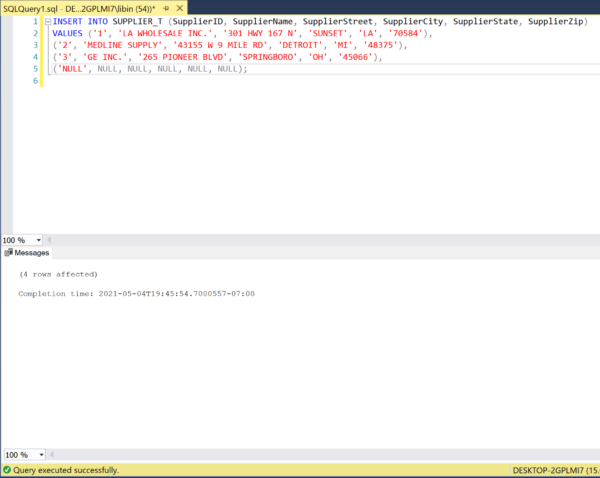

PRODUCT_T

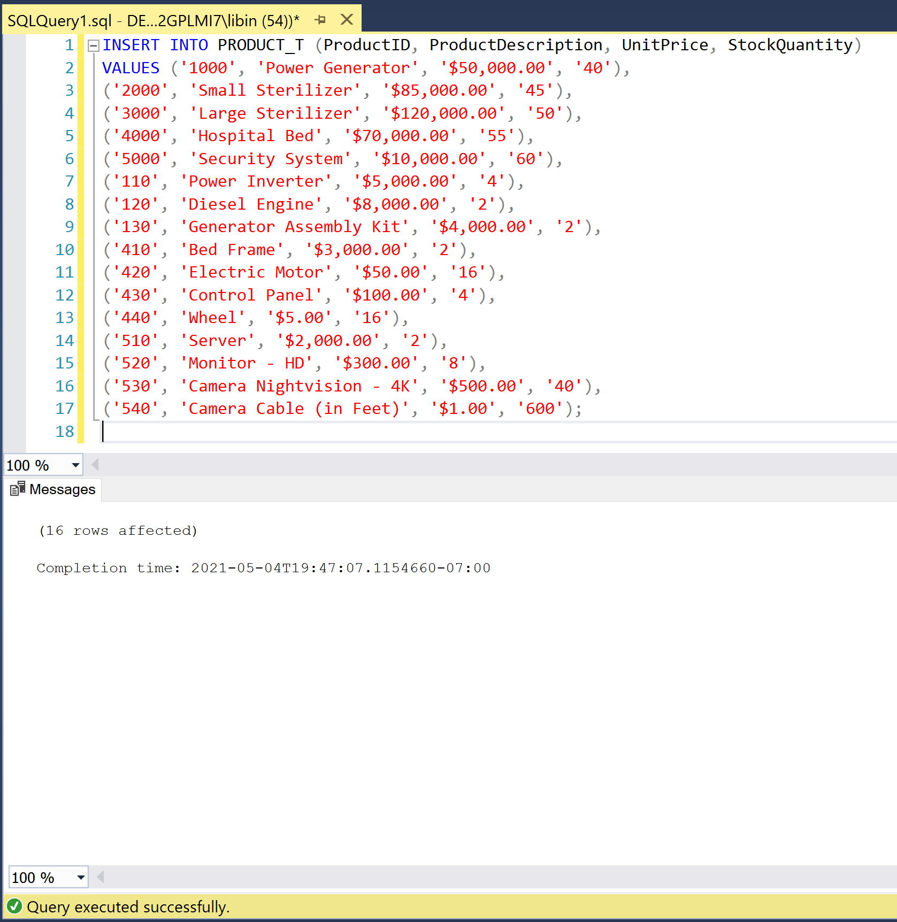

PRODUCT_SUPPLIER_T

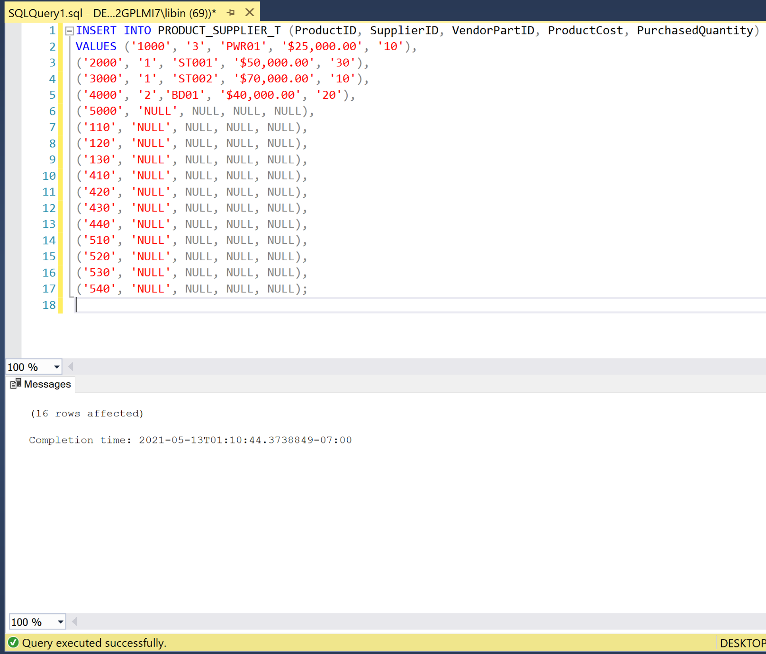

FABRICATED_T

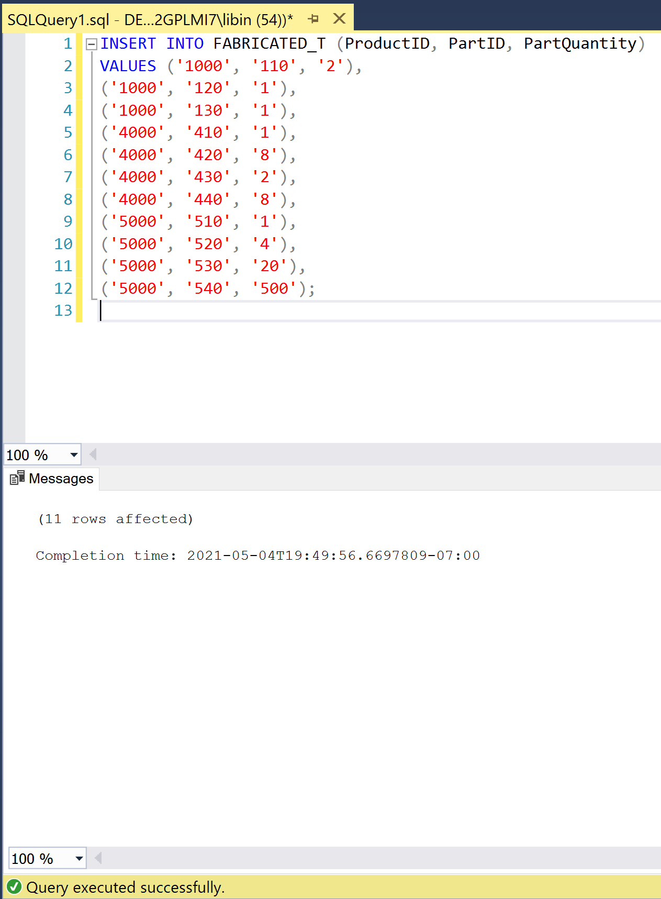

COURSE_T

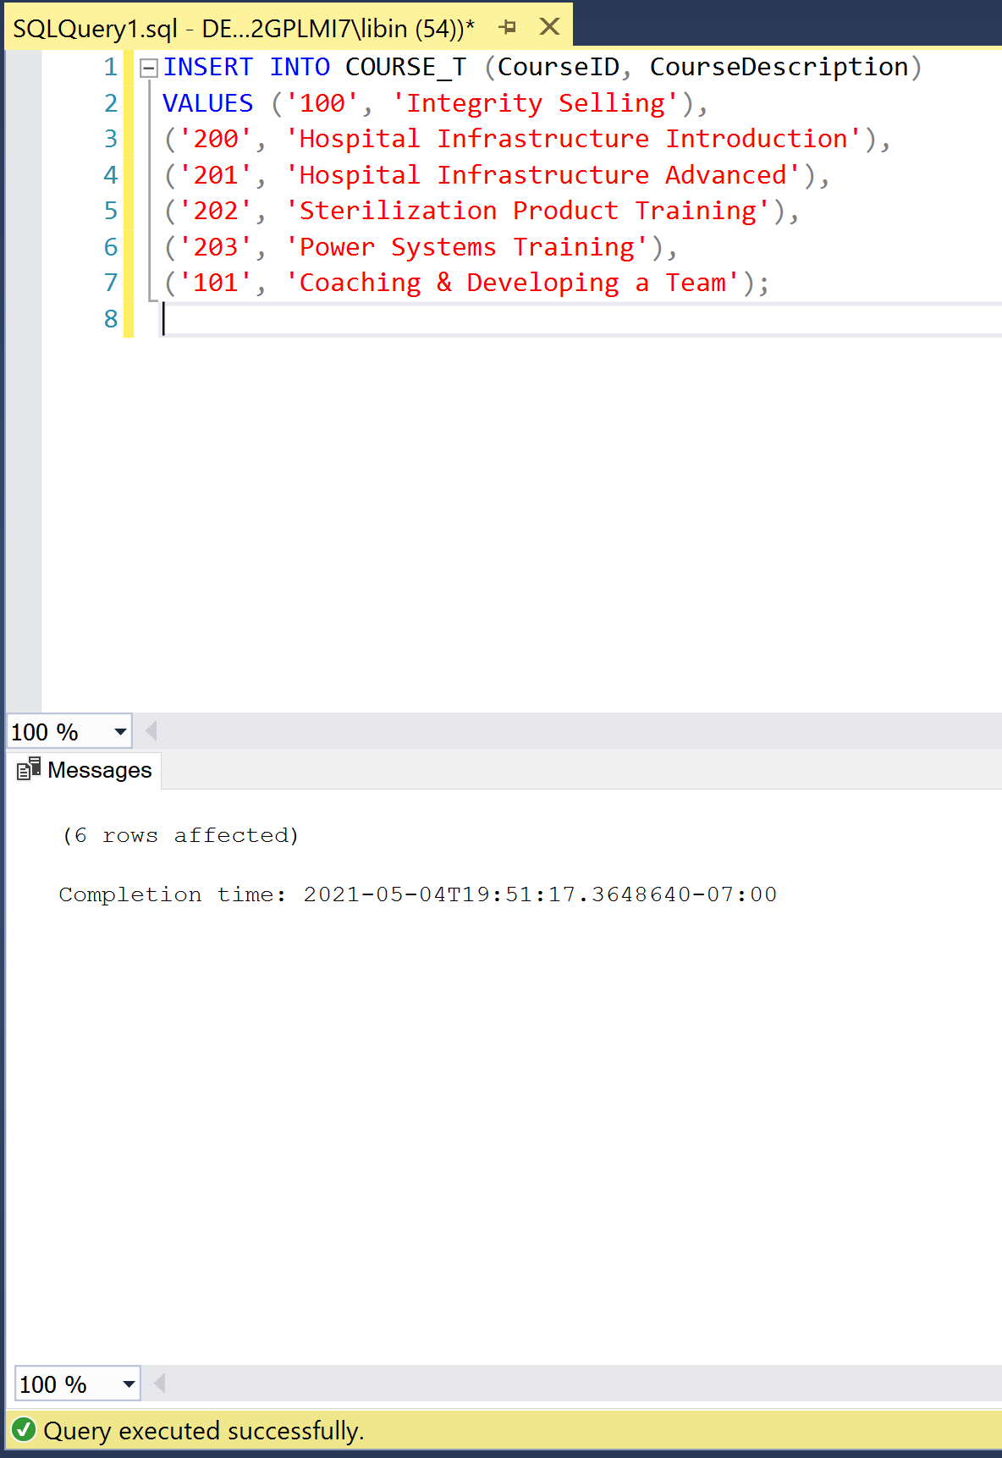

EMPLOYEE_T

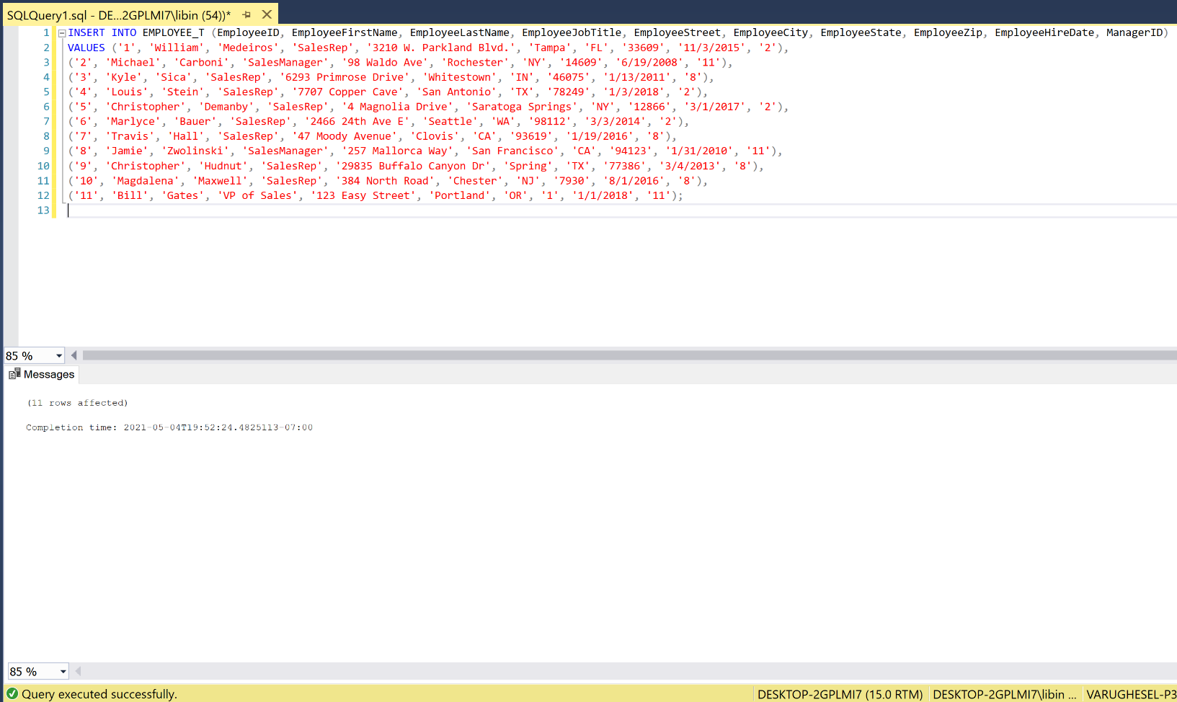

SALES_REPRESENTATIVE_T

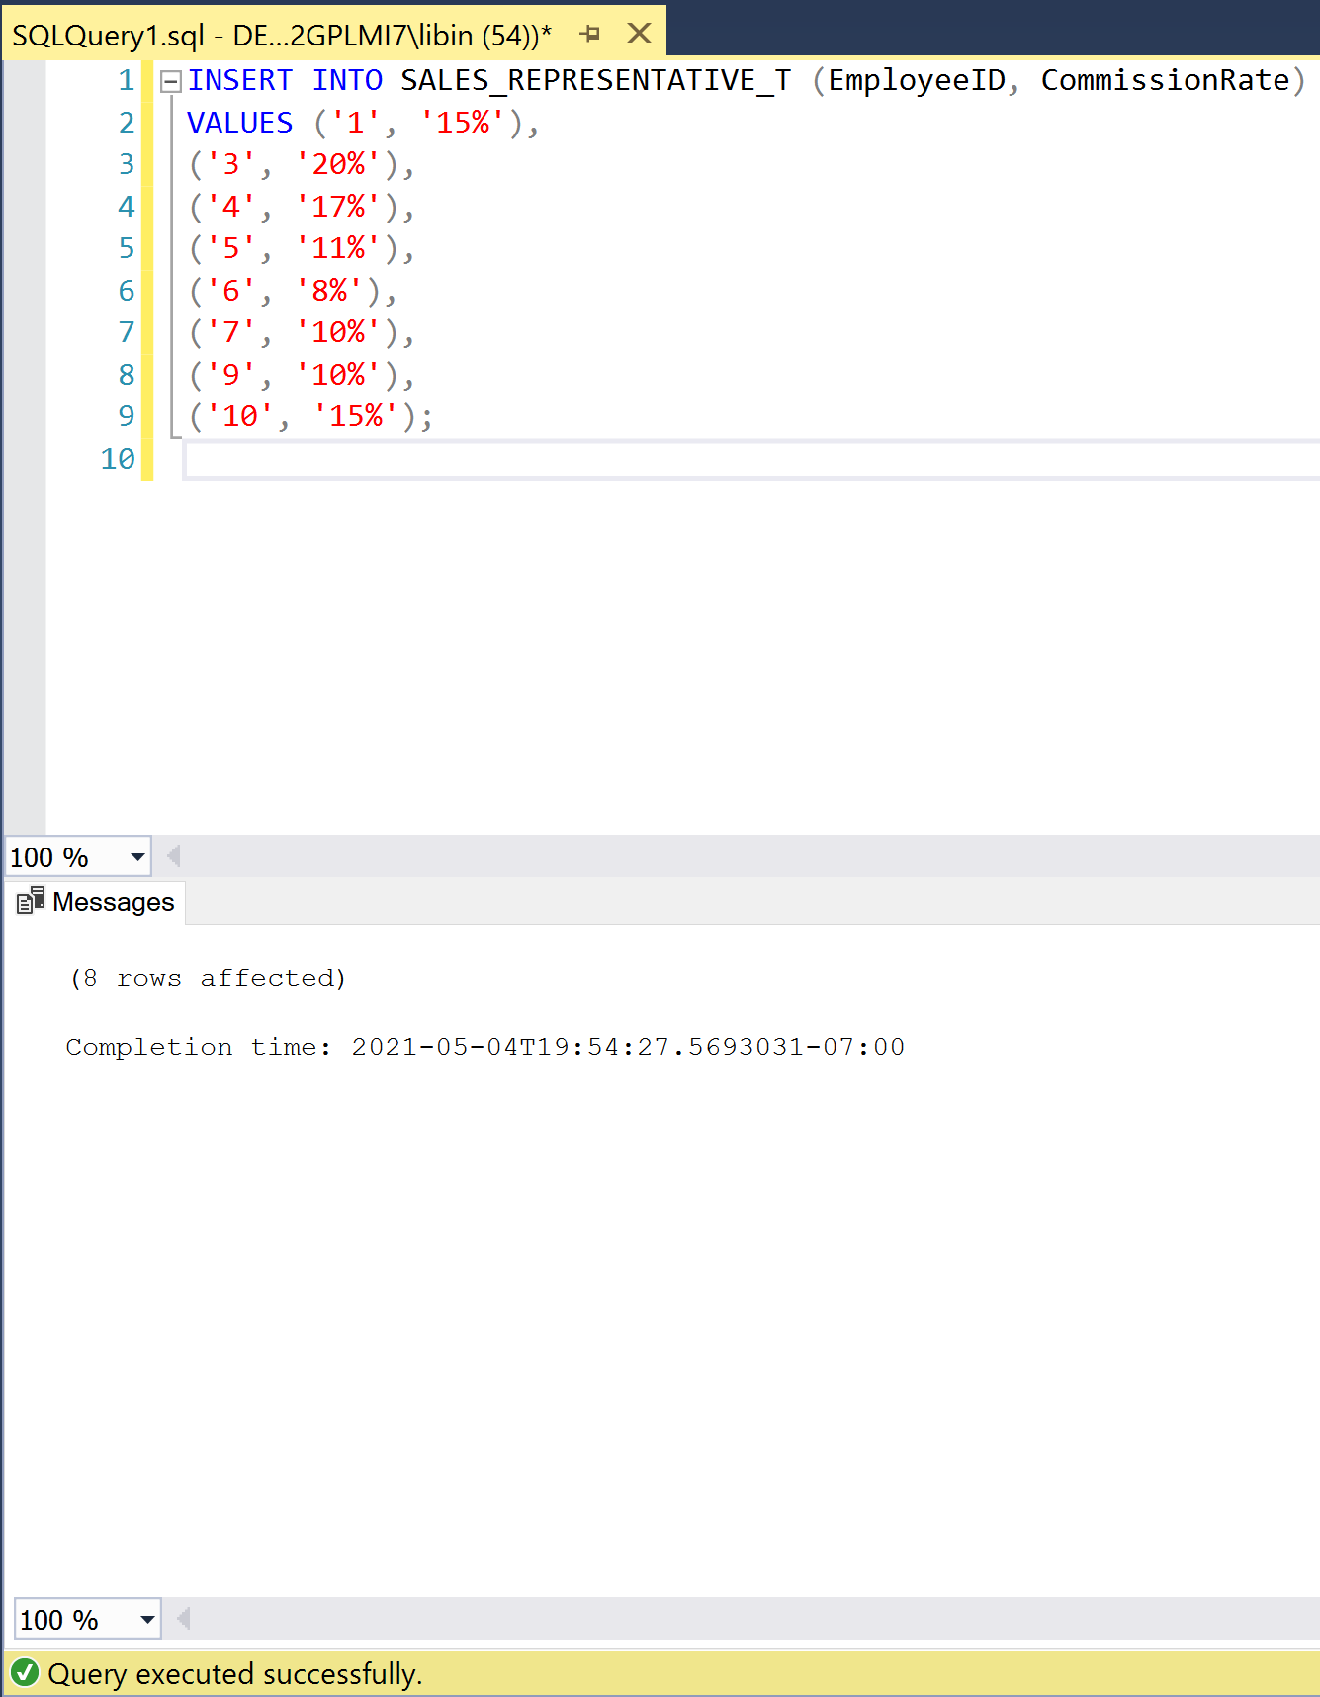

EMPLOYEE_COURSE_T

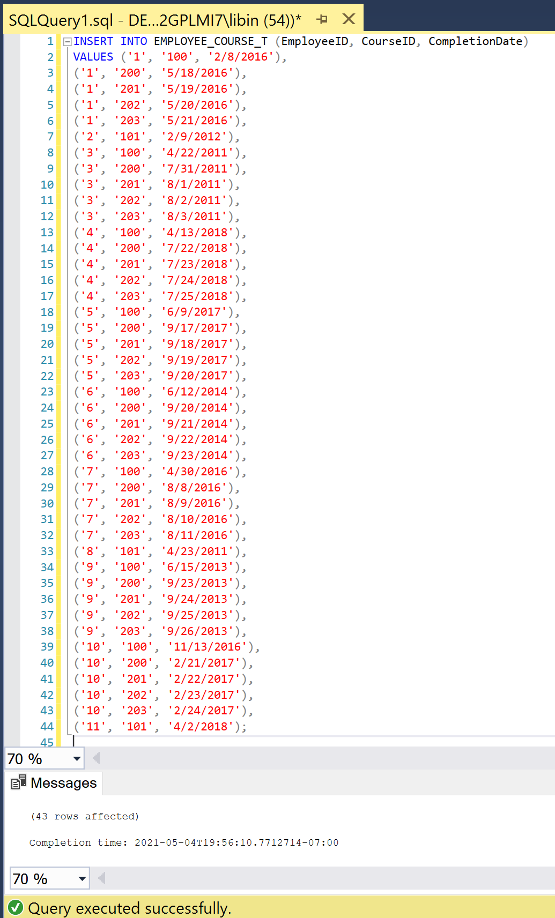

CUSTOMER_T

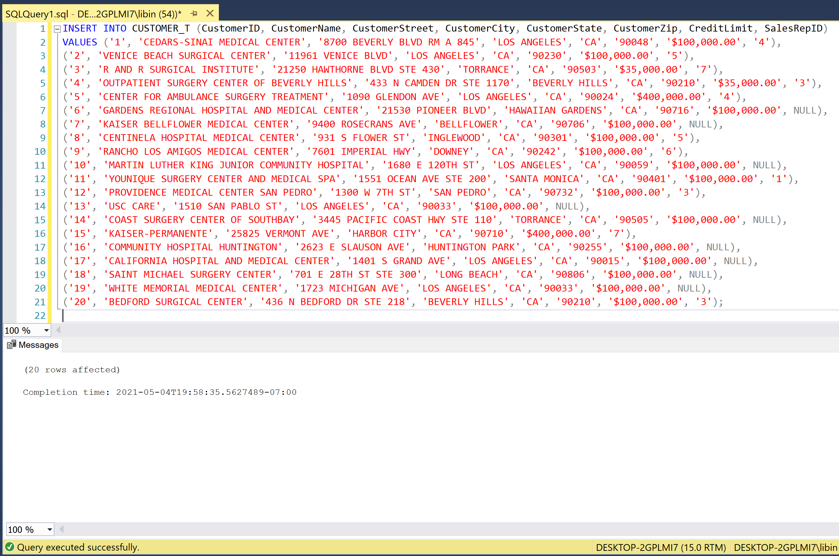

ORDER_T

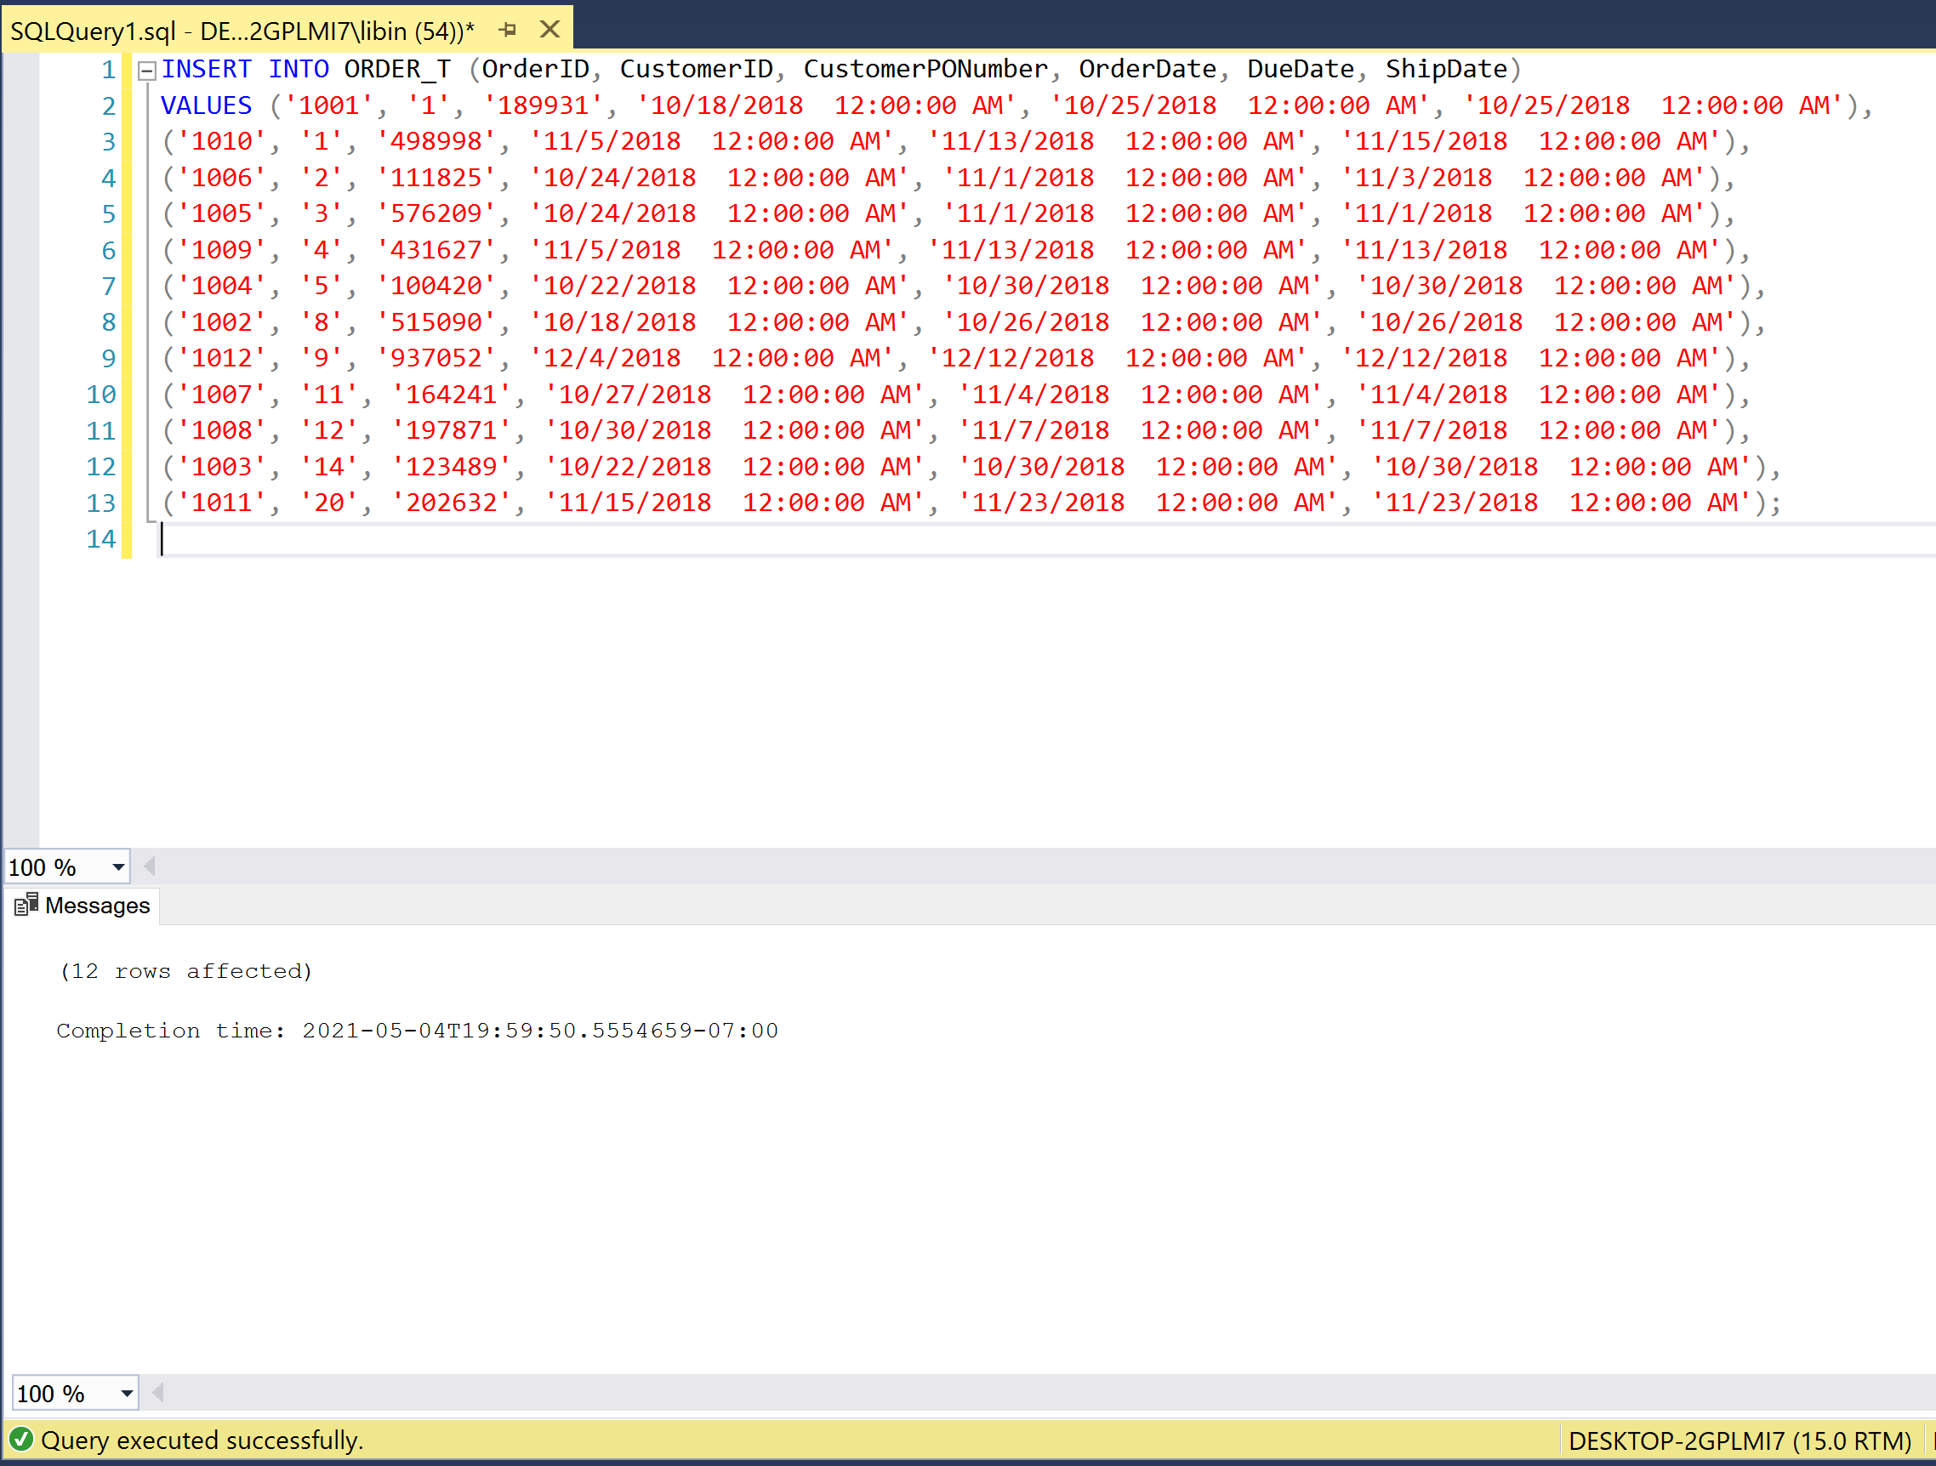

ORDER_LINE_T

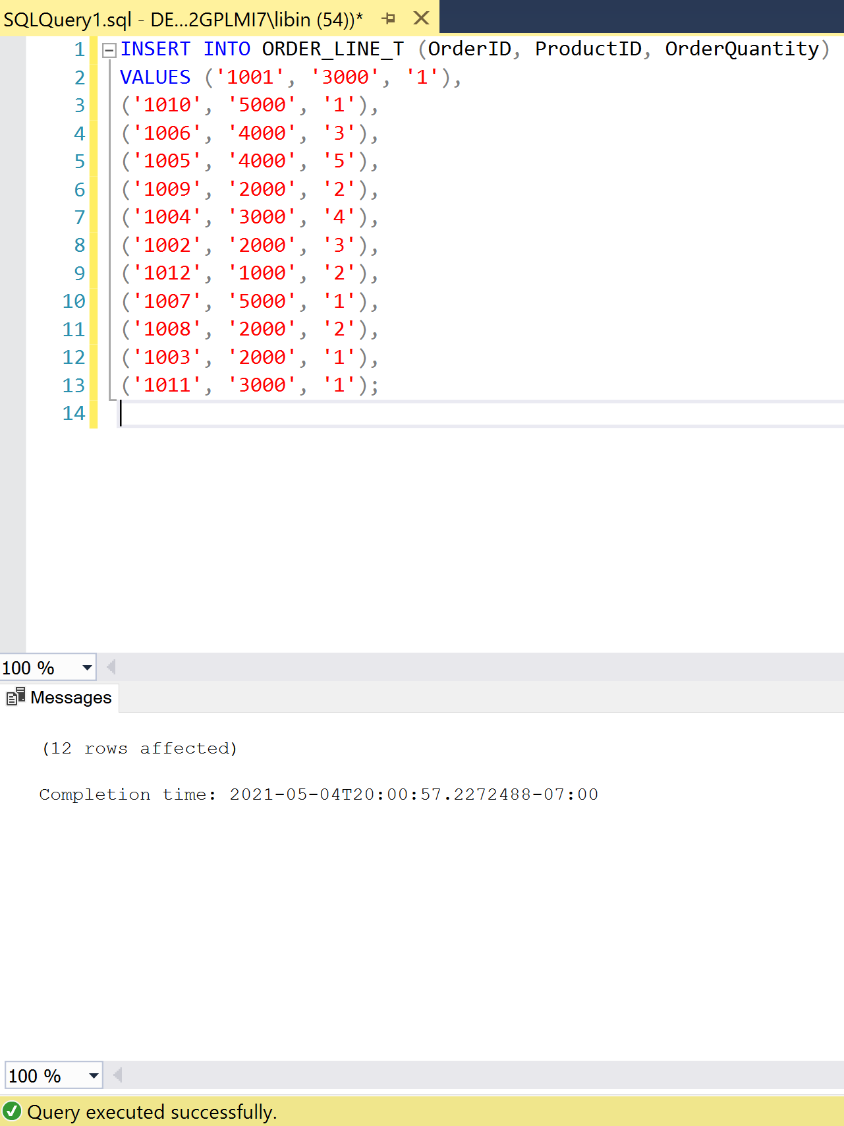

Deliverable #2: SQL Statements

A.) Provide a list of all the Customer ID, Customer Names, and City, and sort the list in alphabetical order by Customer Name.

SELECT CustomerID, CustomerName, CustomerState

FROM CUSTOMER_T

ORDER BY CustomerName;

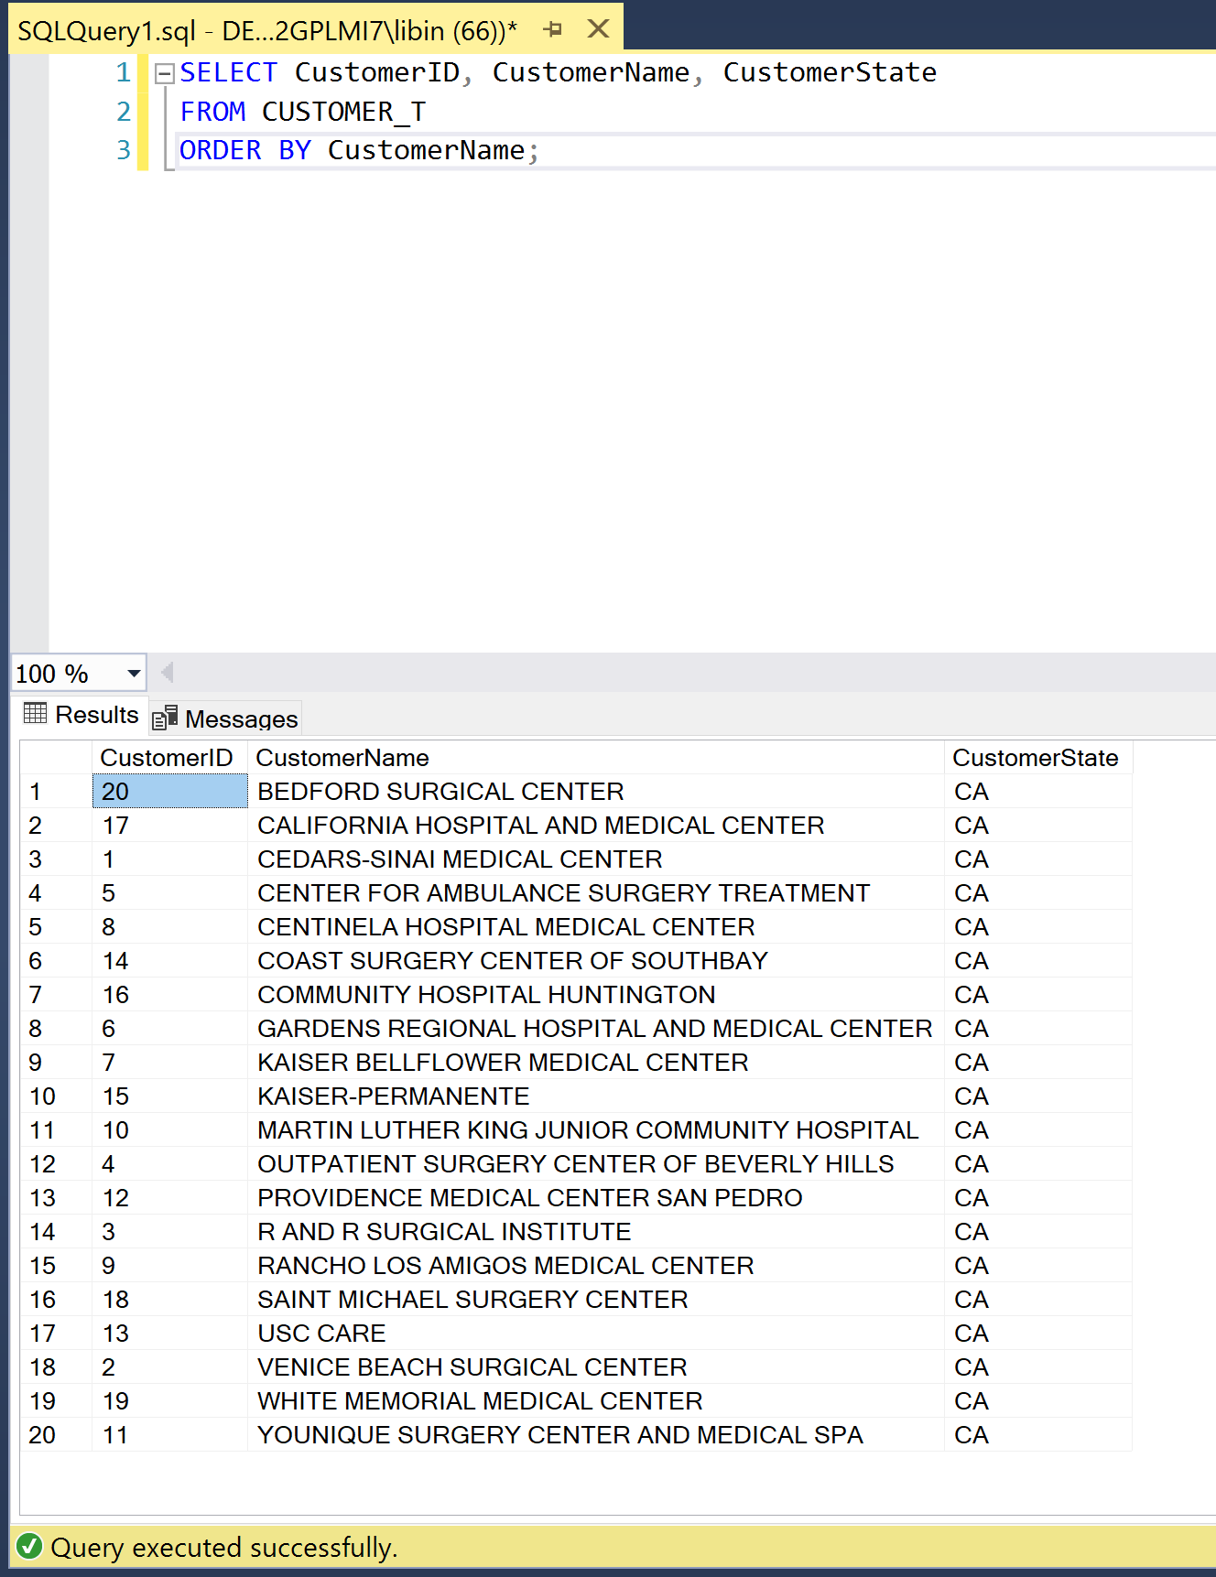

B.) Provide a list of all of the Customer ID, Customer Names, and City, and sort the list by city with the Customer Names in alphabetical order within each city.

SELECT CustomerID, CustomerName, CustomerCity

FROM CUSTOMER_T

ORDER BY CustomerCity, CustomerName;

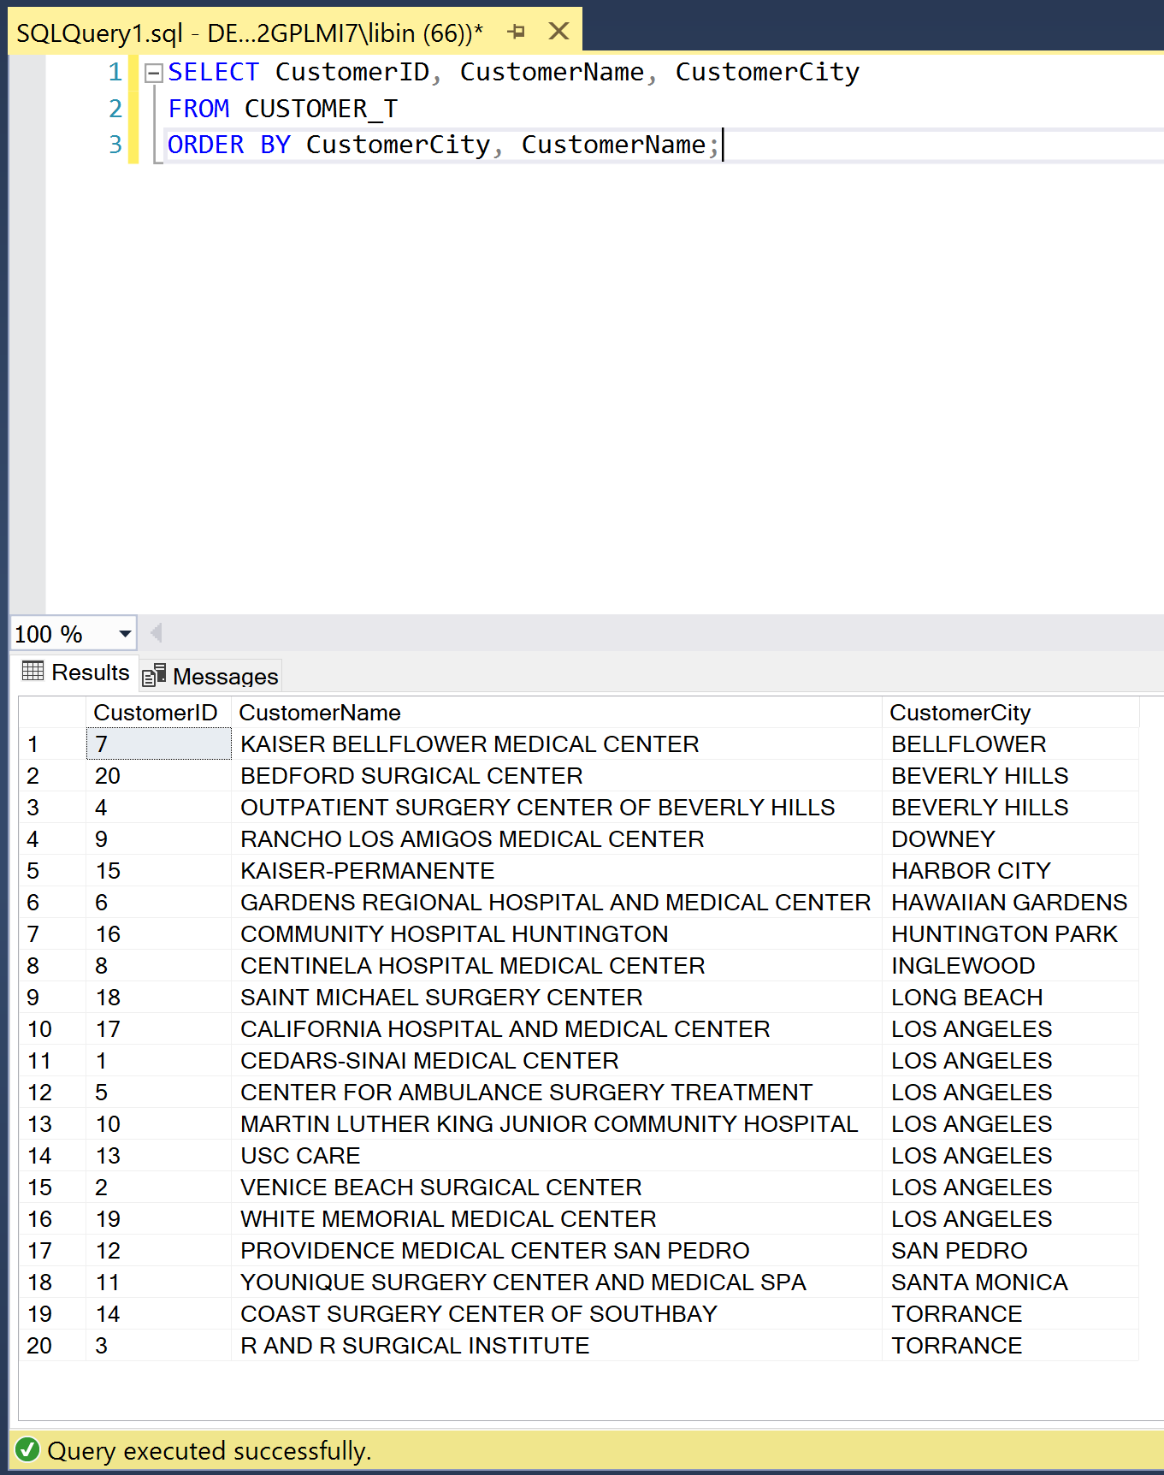

C.) List the customers showing the Customer ID, Customer Name, address, and sales rep name in alphabetical order by customer name.

SELECT CustomerID, CustomerName, CustomerStreet, CustomerCity, CustomerState, CustomerZip, SalesRepID

FROM CUSTOMER_T

ORDER BY CustomerName;

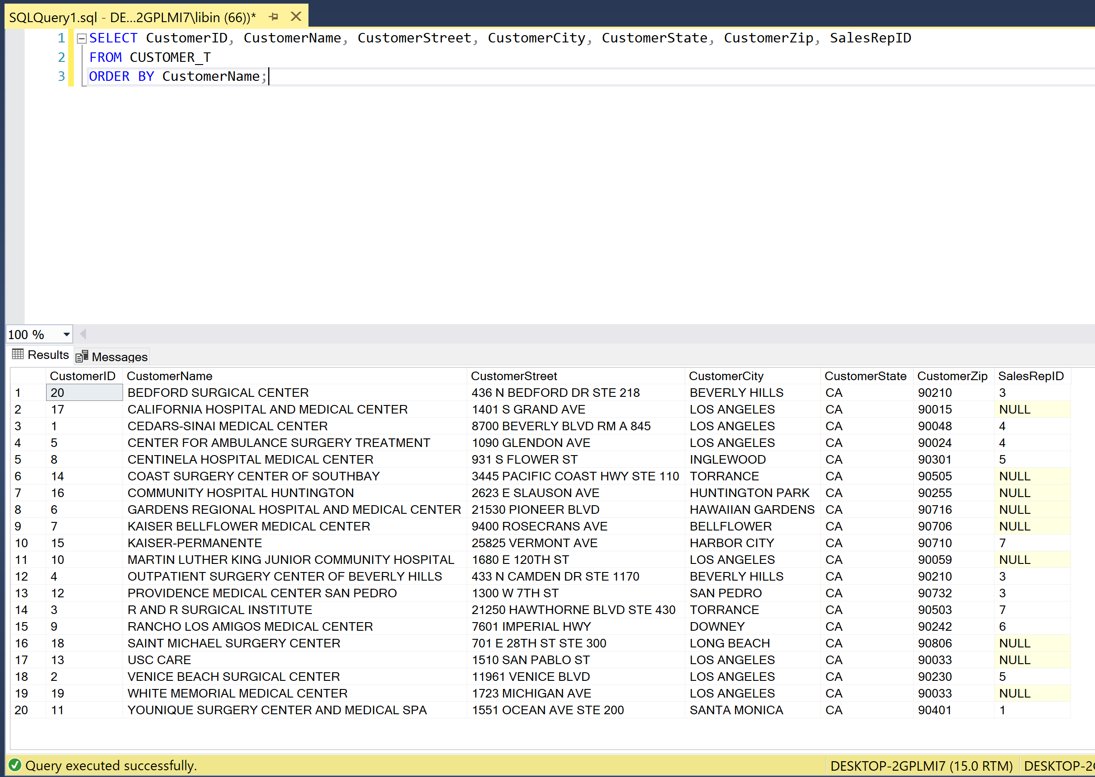

D.) Which employees have not completed course ID = 100?

SELECT EmployeeFirstName, EmployeeLastName

FROM EMPLOYEE_T

WHERE EmployeeID NOT IN (SELECT EmployeeID

FROM EMPLOYEE_COURSE_T

WHERE CourseID = 100);

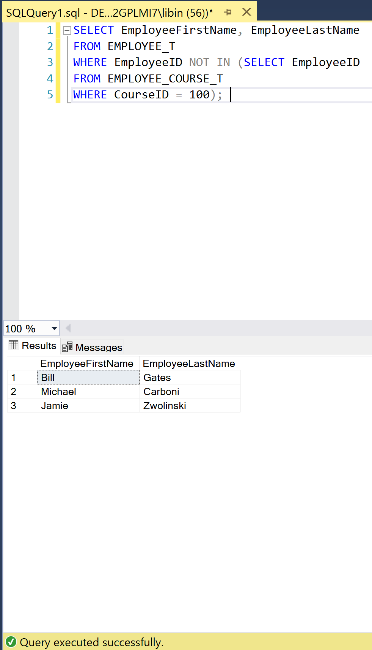

E.) How many sales reps does PSC have?

SELECT COUNT(EmployeeID) AS PSCSalesReps

FROM SALES_REPRESENTATIVE_T;

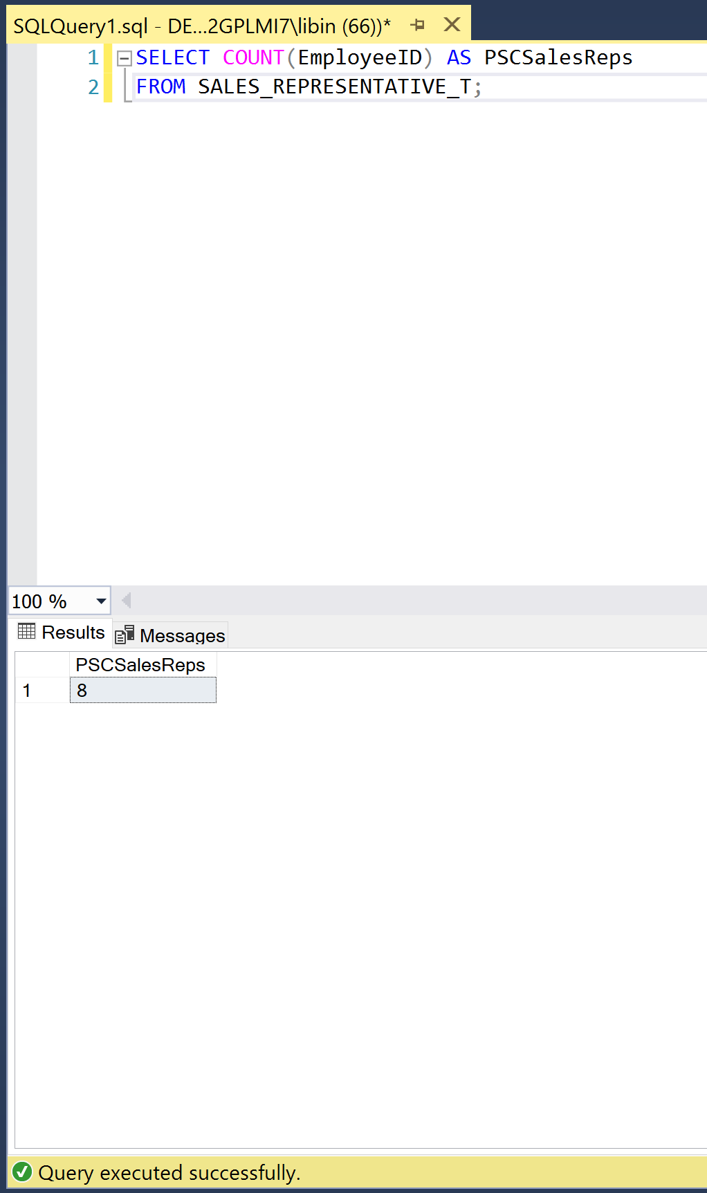

F.) List all of the sales reps sorted by largest commission rate first.

SELECT EMPLOYEE_T.EmployeeFirstName AS SalesRepFirstName, EMPLOYEE_T.EmployeeLastName AS SalesRepLastName, SALES_REPRESENTATIVE_T.CommissionRate

FROM EMPLOYEE_T

INNER JOIN SALES_REPRESENTATIVE_T ON SALES_REPRESENTATIVE_T.EmployeeID=EMPLOYEE_T.EmployeeID

ORDER BY CommissionRate DESC;

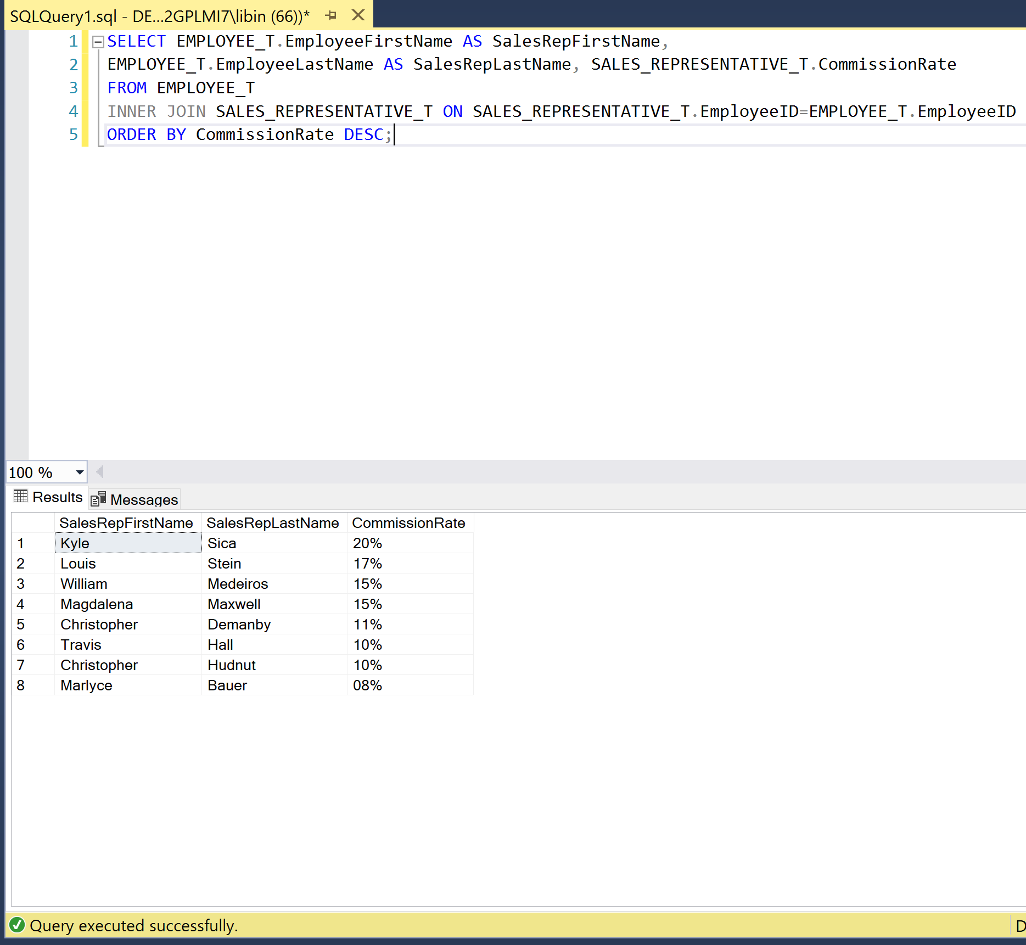

G.) Who are the manager(s) of the sales reps?

SELECT EmployeeFirstName AS SalesRepManagerFirstName, EmployeeLastName AS SalesRepManagerLastName

FROM EMPLOYEE_T

WHERE EmployeeJobTitle = 'SalesManager';

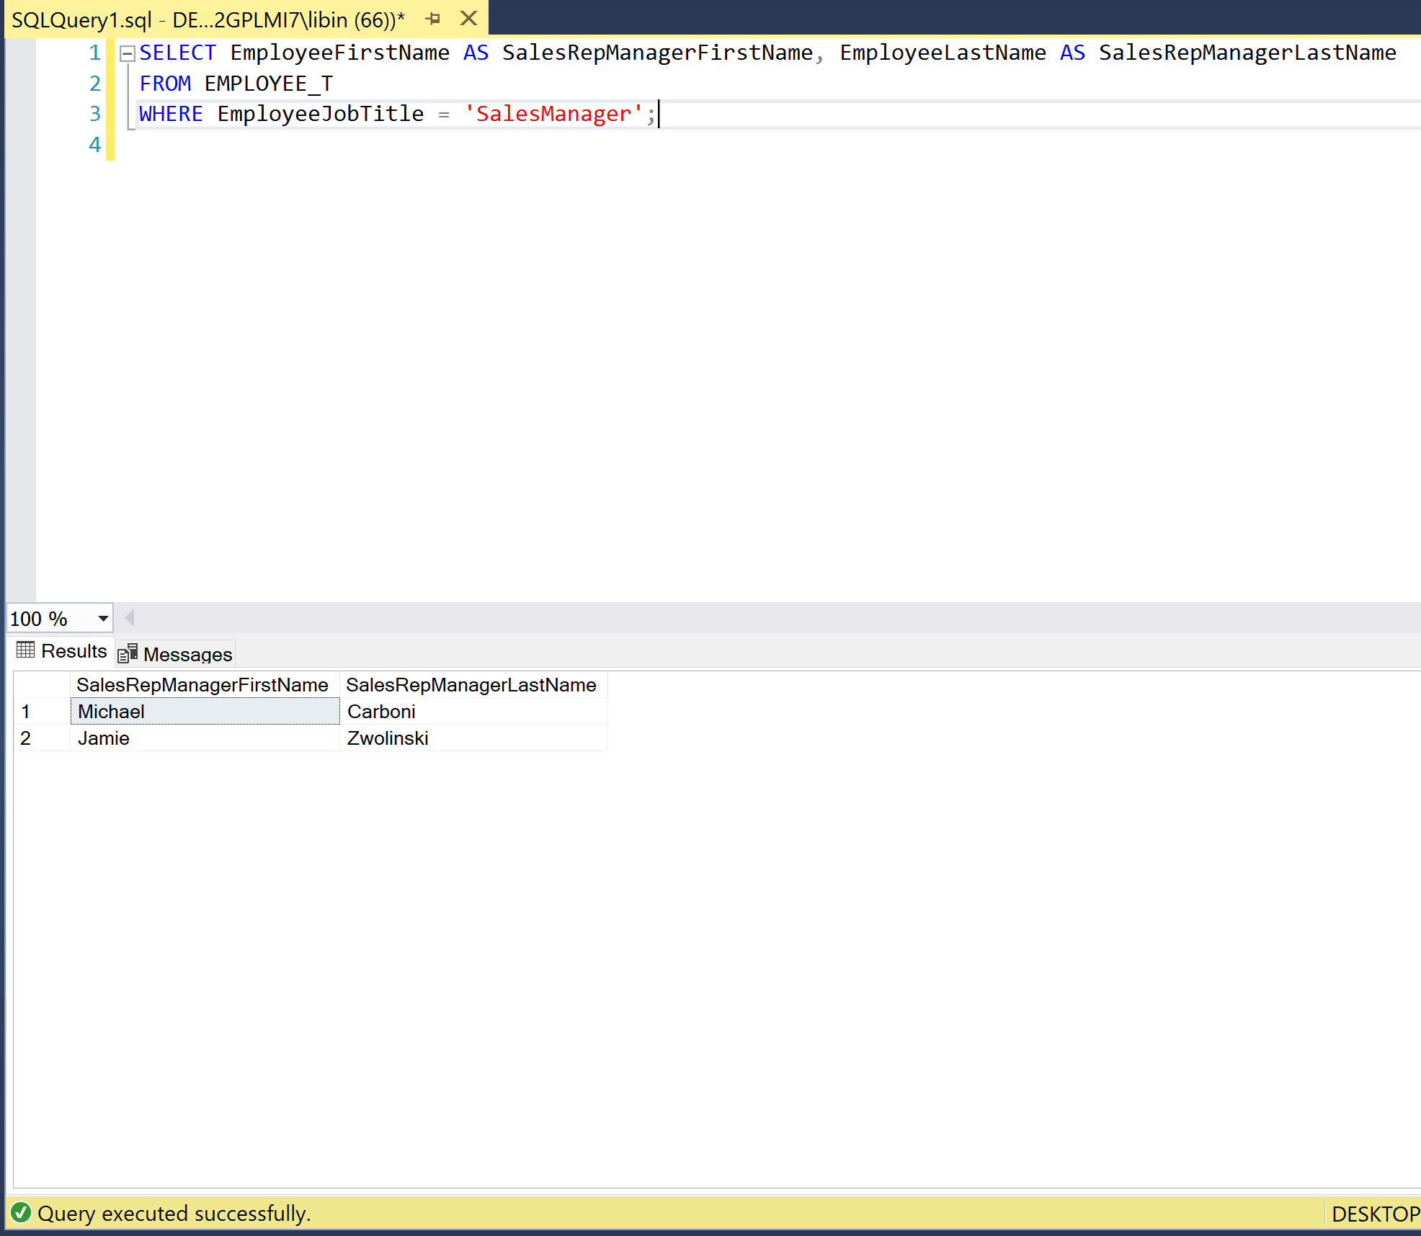

H.) List the employees names who report to a Sales Manager.

SELECT EmployeeFirstName, EmployeeLastName

FROM EMPLOYEE_T

WHERE ManagerID IN(SELECT EmployeeID

FROM EMPLOYEE_T

WHERE EmployeeJobTitle = 'SalesManager');

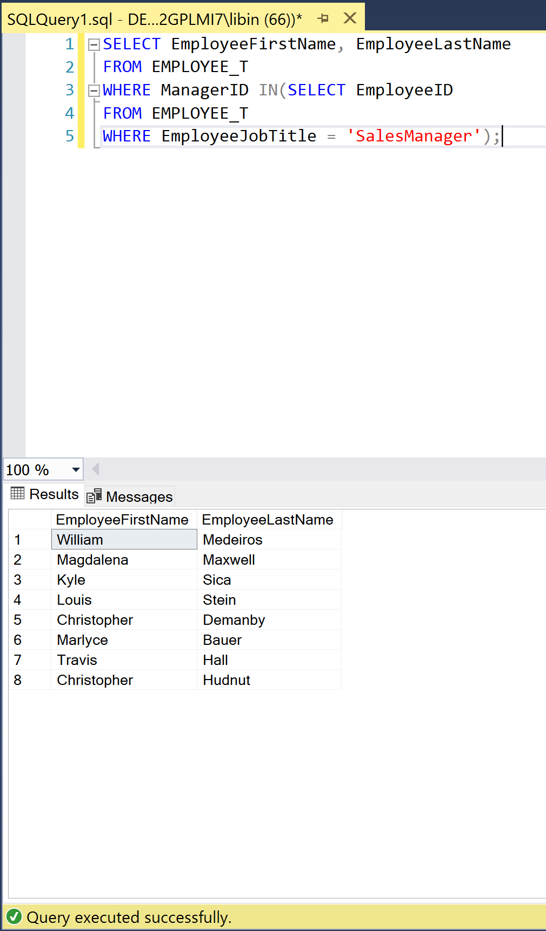

I.) Who is the manager of the manager of the sales reps?

SELECT EmployeeFirstName, EmployeeLastName

FROM EMPLOYEE_T

WHERE ManagerID NOT IN(SELECT EmployeeID

FROM EMPLOYEE_T

WHERE EmployeeJobTitle = 'SalesManager')

AND EmployeeJobTitle != 'SalesManager';

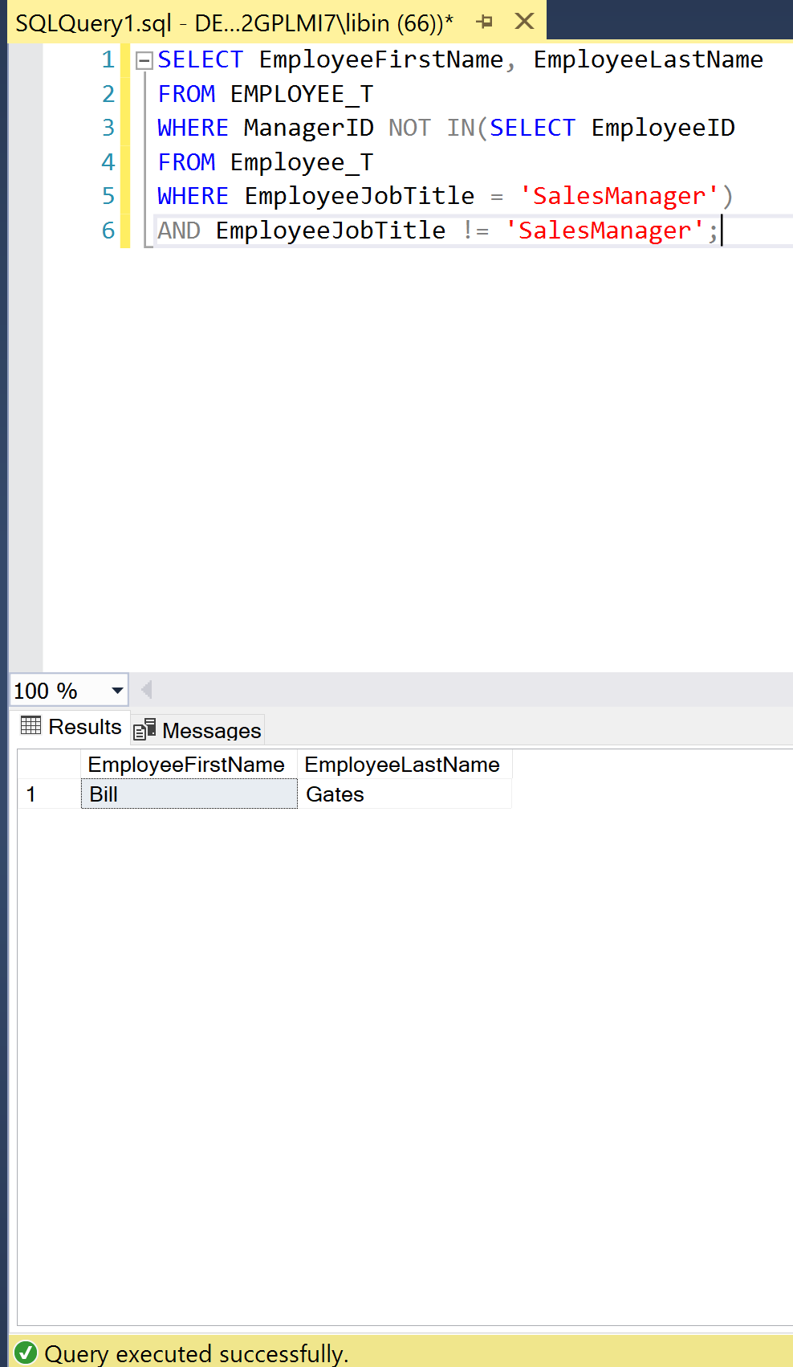

J.) List the employee names of those that report directly to the manager of the sales manager(s).

SELECT EmployeeFirstName, EmployeeLastName

FROM EMPLOYEE_T

WHERE ManagerID NOT IN(SELECT EmployeeID

FROM Employee_T

WHERE EmployeeJobTitle = 'SalesManager');

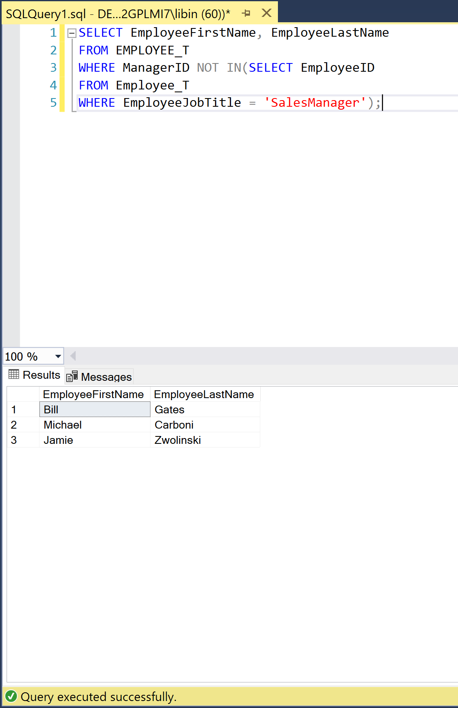

K.) Provide an inventory report that lists the most costly items first. The inventory report should include product identification numbers, product descriptions, unit prices, supplier names, cost, and quantity supplied.

SELECT PRODUCT_T.ProductID, ProductDescription, UnitPrice, SupplierName,

ProductCost*PurchasedQuantity AS Cost, PurchasedQuantity AS QuantitySupplied

FROM PRODUCT_SUPPLIER_T

INNER JOIN PRODUCT_T ON PRODUCT_SUPPLIER_T.ProductID = PRODUCT_T.ProductID

INNER JOIN SUPPLIER_T ON PRODUCT_SUPPLIER_T.SupplierID = SUPPLIER_T.SupplierID

ORDER BY Cost DESC;

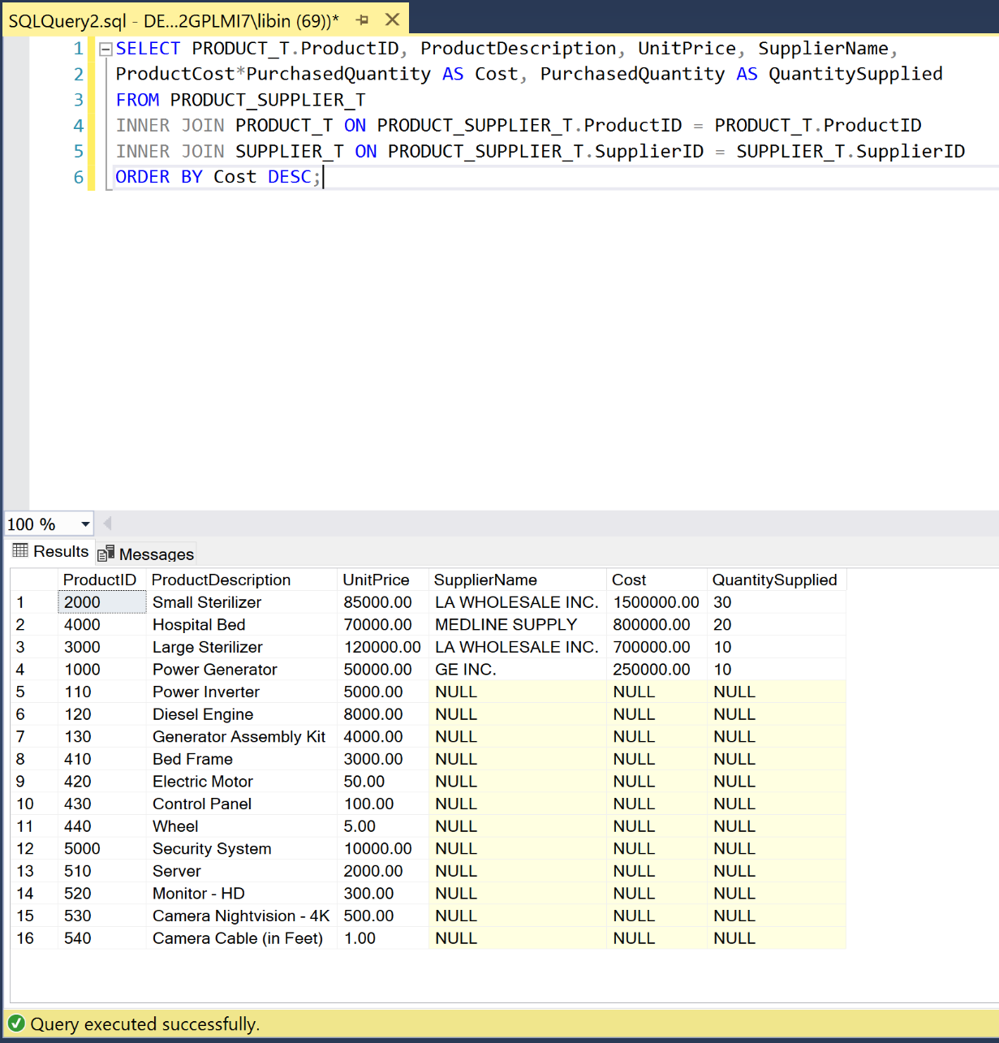

L.) List all of the employees in alphabetical order and each course they have completed in order of date completed.

SELECT EmployeeFirstName, EmployeeLastName, COURSE_T.CourseID, CourseDescription, CompletionDate

FROM EMPLOYEE_COURSE_T

INNER JOIN EMPLOYEE_T ON EMPLOYEE_COURSE_T.EmployeeID = EMPLOYEE_T.EmployeeID

INNER JOIN COURSE_T ON EMPLOYEE_COURSE_T.CourseID = COURSE_T.CourseID

ORDER BY EmployeeLastName, CompletionDate;

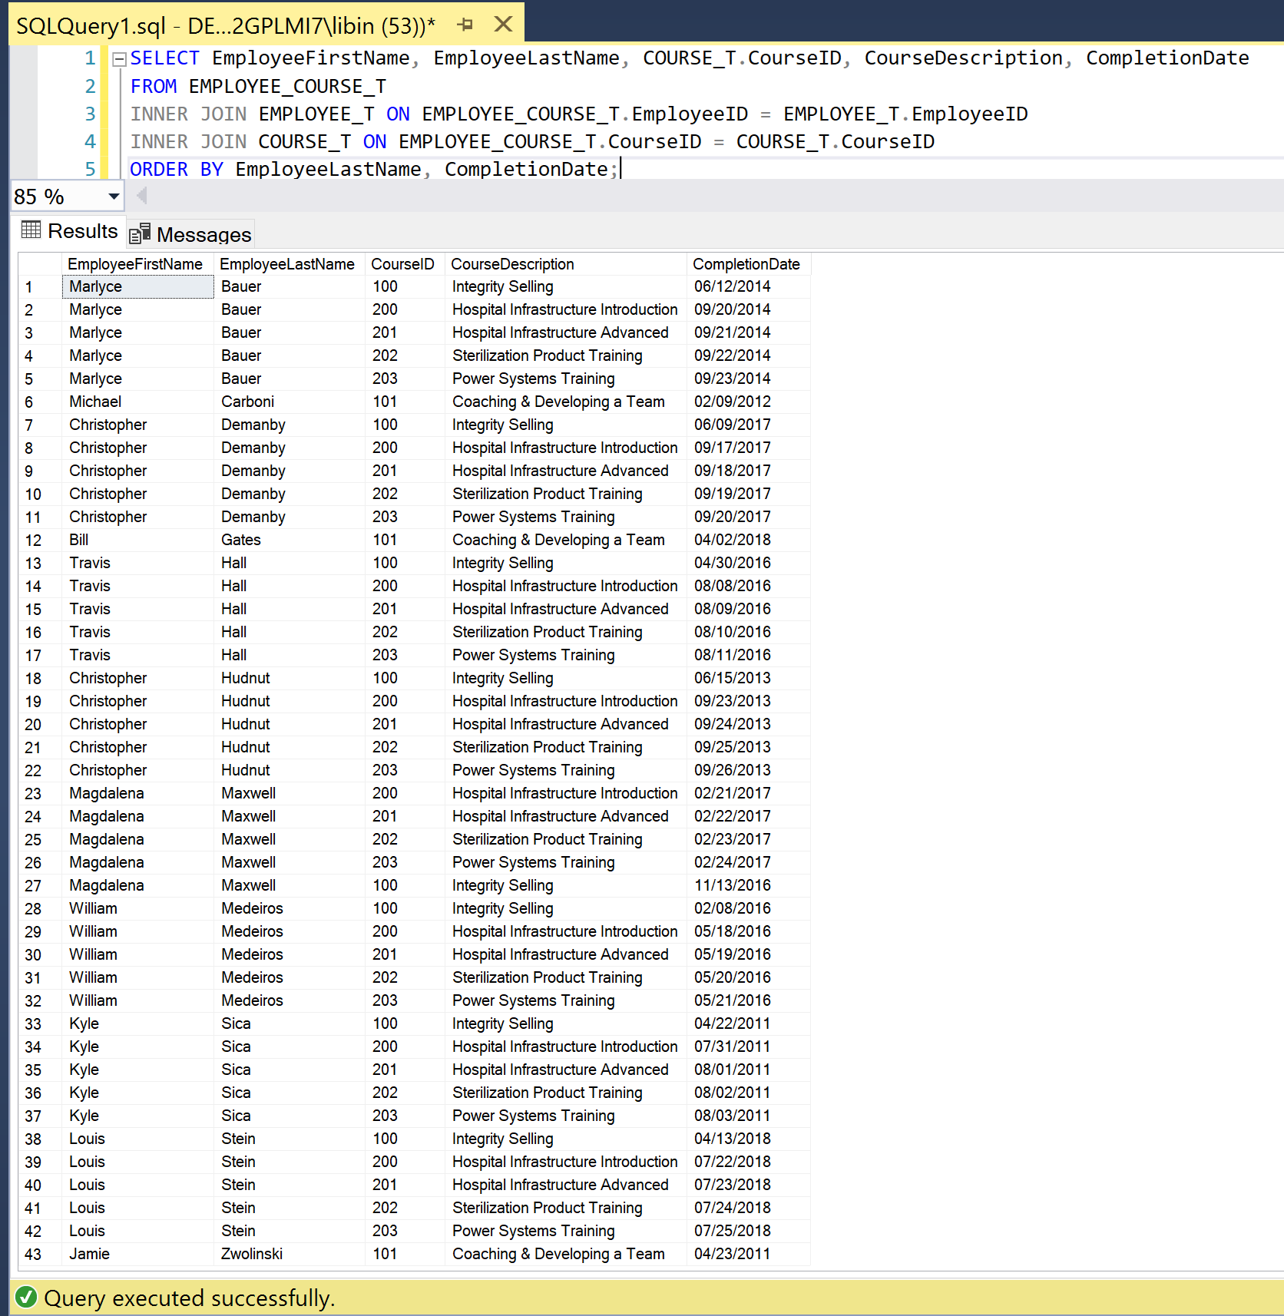

Statement of Academic Integrity

CLASS POLICY ON ACADEMIC INTEGRITY As business professionals we have an ethical duty to uphold the reputation of the businesses we work for by following the company’s standards of personal integrity and trustworthiness. As business students we have an ethical duty to uphold the integrity of our coursework and the honorable reputation of our school by following the guiding principles of our school policies, including University Policy on Academic Dishonesty.

As CIS 3050 business students we must pledge to:

✓ Create and produce our own work;

✓ Treat teammates with respect;

✓ Give our utmost in performance; and

✓ Use legitimate information sources.

Learning and following these guiding principles will have a positive and lasting impact on your future as a business professional. By violating class policy and acting dishonorably, students demonstrate their lack of readiness to enter into CIS professions. Students choosing to violate University Policy on Academic Dishonesty will face the consequences as described in that policy.

I, Libin Varughese, hereby affirm that I have not received any outside help on this project and that the work presented here is solely my own.

Signed: Libin Varughese